**Features:**

1 High-precision imported sensors: PM2.5, PM10, CO2, HCHO, VOC, temperature and humidity, etc.

2 The system is configured with multiple sensors, including illumination, vibration, and PCB temperature detection.

3 2.8-inch color TFT display with color screen display.

4 Touch sensing, vibration sensing, light sensing, intelligent adjustment of screen brightness at night.

5 In addition to the 5V USB power supply, it is equipped with a large-capacity imported lithium battery to provide air movement for air quality detection.

6 Built-in SD card, standard configuration 2G SD card, can store 5 years of sensor data, support up to 32GB SD card.

7 can connect to the computer to view sensor data, virtual U disk supports FAT, FAT32, exFAT file system.

8 Support online upgrade firmware, support remote firmware upgrade.

9 equipped with WIFI module, support network control function

10 Optional GPRS module, can be placed outdoors, remote detection in the deep forest.

11 Configure the mobile app, including IOS and Android versions.

12 Supports up to 2A fast charging function to quickly fill the battery.

13 Keep the external interface and connect other sensors such as oxygen, carbon monoxide, etc.

14 Scrubed acrylic shell, so addictive ^-^.

15 black gold plated PCB, noble and generous, lead-free solder, components are RoHS compliant.

Sensors:

**CO2**  : Sweden SenseAir LTD, S8 0053 CO2 Sensor

**Formaldehyde:** England DART SENSORS LTD, WZ-S Module

**PM2.5/PM10:** China PlantPower LTD, PMS7003, PMS7003M

**Temperature & Humidity:** Switzerland SENSIRION LTD, SHT20 Sensor

**VOCs:** China Winsensor LED, ZM01 IIC BUS VOCs MEMS Sensor

**Others:**

Photoresistance,

PCF8563 RTC Clock,

MCU: STM32F103RCT6(64K RAM, 256K ROM),

ETA9742 3A Switching Charger

WIFI Module: ESP-8266

**resources:** [**https://github.com/SaberOnGo/AirDog**](https://github.com/SaberOnGo/AirDog)

includes: Schematic, Code, Data Sheet and so on.

1 WIFI:

my ESP8266 sdk in: <https://github.com/SaberOnGo/ESP8266-AIRDOG>

ESP8266(ie: ai-thinker ESP-12F, esp8266 with 32Mbit SPI FLASH)

<http://wiki.ai-thinker.com/esp8266/docs>

ESP8266 SDK and resources on Espressif:

<https://www.espressif.com/en/support/download/sdks-demos?keys=&field_type_tid%5B%5D=14>

**Usage:**

1. **Long press the left button(power button) to power on. When on running, Long press the left button to power off.**

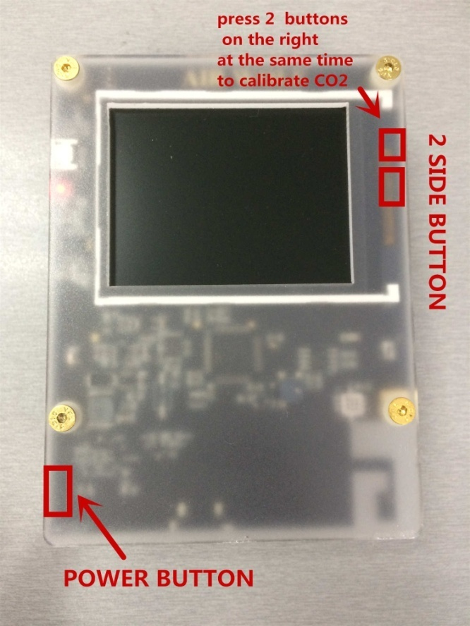

**2 Unpack the package for the first time, first boot for more than 6 HOURS!**

First plug in the USB charger, place it in a well ventilated place, and turn it on continuously for more than 6 hours. The purpose is to let the probe heat itself and dissipate the plastic smell in the package. During this process, the TVOC value and the formaldehyde value will gradually decrease, which is the normal process of the probe itself to preheat and remove the pollutants.

**3 After booting for more than 6 hours, keep it turned on and perform the first outdoor adjustment.**

VOC and formaldehyde sensors are factory calibrated, and users do not need to calibrate for operational difficulties.

The CO2 sensor requires user calibration. Please keep it on after 6 hours of power on, then leave it outdoors for 30 minutes (preferably in a cool place) until the value is reduced to a minimum.

At this time, **press** and hold the side **2 keys on the right** **at the same time**, and you will hear a “click” and let go. At this point, the bottom right corner of the screen prompts you to calibrate: “CALI...”

If the calibration is successful, the word CALI OK will be displayed. If prompted, Failed, recalibrate until CALI OK appears.

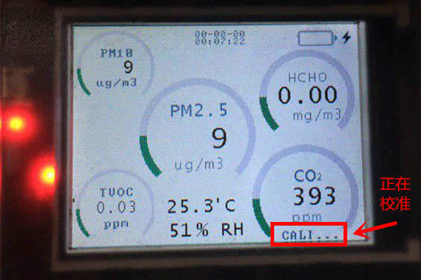

calibrating co2 sensor

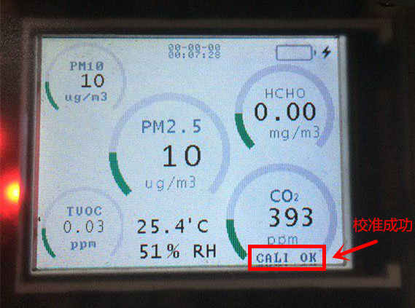

calibrate co2 sensor OK

This step is to give the machine a clean background air value. Just like the zeroing of the balance and the electronic scale, it must be done. It is to eliminate long-term drift. Once you've adjusted it, you're ready to use it, and you can do it every 3 months. Usually used, no need to zero each time. After 10 minutes of power on, the reading is ready.

**How to use it normally?**

Boot for 10 minutes (anywhere), then you can see the data.

**How to accurately detect formaldehyde?**

1, first,indoor ventilation

2, close the doors and windows for 12 hours (preferably no one in the room)

3, do not use perfume, face cream, facial milk, cooking, cooking, such artificial chemicals. In order to avoid interference, whick make the value is too high.

**How has VOCs been always 0?**

1 The reason is that you have not done the first zero adjustment of the machine, or you have incorrectly zeroed when the boot time is not enough. Please follow the steps above to re-zero the outdoors.

2 If you have correctly adjusted to the zero, don't worry.

**HCHO( formaldehyde) value is suddenly high?**

After the meal, the value will be higher because the organic matter accumulated in the room is excessive after cooking.

If you encounter sudden increase in formaldehyde, pay attention to whether there are any cooking, alcohol, perfume (fragrance gas), smoking, etc. in the environment. When testing formaldehyde, you need to avoid these artificial cross-interference factors. It is recommended to ventilate the test first, then seal the room for 12 hours. Testing the rooms that are not in check-in is the best.

**Formaldehyde is 0.08~0.09 ppm, Can I stay in room?**

If the room is detected at night, and someone has already settled in. Then this value may be that the room is closed for too long, or the cooking fumes, and the chemical interference caused by the lack of air circulation. Generally, by completely changing the wind, it can be lowered to 0.05, which is safe to stay. No need to worry. If it is a new home, no one is stationed, there is no human interference, the value is 0.09, or even more than 0.1, then you can not settle in, ventilation is considered for a period of time.

**The parts are not plugged in? How to check?**

The parts are hot-swappable, and if a probe is not plugged in, system will find, then the sensor's ring will continue to circle.

**Precautions:**

**When** it is used upright, it can be placed on a flat surface, carefully dropped, and the outer casing is made of acrylic material, which needs protection.

**Do** not hold the right side of the machine while moving the test. Use the left hand to hold the left side to avoid affecting formaldehyde.

**Do** not put it on the bed

It takes 30 minutes to warm up for the first time, and then warm up for 10 minutes each time.

**To** measure formaldehyde, it is necessary to close the doors and windows in advance for 12 hours and then measure it according to the national standard GB/T18883.

**Do** not blow in the sensor, it is easy to cause the sensor to overload, the sensor will be difficult to recover zero.

**If** the above situation occurs, you need to manually correct 0 points.

**Dust**, sand (gravel) and other non-smog weather can interfere with the laser detector. At this time, the value error of PM2.5 will deviate.

**Do** not short the two poles on the left and right sides of the battery. Do not place it in a hot environment.

**Keep** away from silicon steam, shampoo, alcohol, kitchen cooking, etc.

**The** first time the machine is turned on because of the smell in the machine package, it will affect the boot value. It needs to be turned on for 6 hours to dissipate the odor absorbed by the probe, and then test it.

**Do** not zero the probe immediately after receiving the machine. It is important to fully warm up and warm up.

AIRDOG Detect Items:

|  |  |  |  |  |  |
| --- | --- | --- | --- | --- | --- |
| **English name** | **Chinese**  **Name** | **Relative error** | **Resolution** | **Range** | **Pollution limit** |
| PM2.5 | 细颗粒物 | ±10ug/m3 | 1ug/m3 | 0-999 ug/m3 | >50ug/m3 |
| PM10 | 可吸入颗粒物 | ±10ug/m3 | 1ug/m3 | 0-999 ug/m3 | >50ug/m3 |
| HCHO | 甲醛 | <±0.02mg/m3 | 0.01mg/m3 | 0-3.0mg/m3 | >0.1mg/m3 |
| VOCs | 挥发性有机物 | <±0.1mg/m3 | 0.01mg/m3 | 0-3.0mg/m3 | >0.6mg/m3 |
| CO2 | 二氧化碳 | ±50ppm | 1ppm | 0-5000ppm | >1000ppm |
| Temp… | 温度 | <±1.0’C | 0.1’C | -25 ~ 85.0’C |  |
| RH… | 湿度 | <±5% | 0.1% | 0~99.0% |  |

Relative cross-interference characteristics of formaldehyde: CO 1%, H2S no data, H2 0.1%, SO2 12%, NO2 no data, NO no data, Cl2 -3%, C2H4 no data, NH3 0%, CO2 0%, methanol 50% ethanol, 7% phenol, 0% water vapor. When detecting formaldehyde, keep away from alcohol, vinegar, and other volatile substances to avoid cross interference. It is recommended to test during the day without cooking.

**How to set system time?**

1 Connect the device and computer with the micro-USB data cable. Generally, XP, WIN7 is OK, WIN8, WIN10 have not been tested.

2 2MB - 4MB disk appears in the computer, generally there are 2 disks, the larger disk is the SD card, the smaller is the system configuration disk.

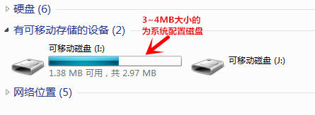

3 Enter the disk, you can see several directories and files:

./font : storage system fonts, users can't move! ! !

./sensor: store sensor datas, when the user does not insert the SD card, the system will save the sensor data in the flash disk.

 ./update: upgrade file directory, users can copy the bin file provided by the author into this directory, restart boot, you can upgrade the system.

 ./config.txt, user profile, the user can modify the parameters inside, including time.

 ./default system configuration file, the user cannot modify it, otherwise it will not run normally.

./system system configuration file, the user cannot modify it, otherwise it will not run normally.

4 Open the config.txt file with the Notepad tool that comes with your computer:

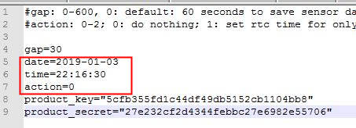

**gap**: refers to how many seconds the system records the sensor data. The default gap=30 is to save the sensor data every 30 seconds.

**date**: set the date;

**time**: set the time;

**action**: notify the system to write after setting the date and time. action=0, no write; 1: write once.

For example, if you want to set the time to 22:16:30 on February 11, 2019, set it as shown below, pay attention to: **action=1**

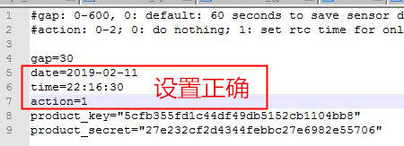

5 Shut down, then reboot, the system is written time:

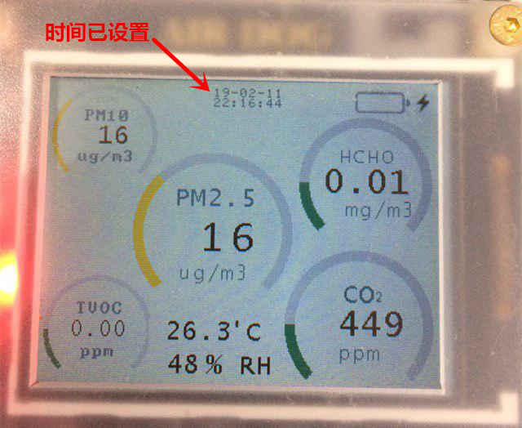

6 **Precautions:**

If you can't open the disk file, or you are stuck there, you can shut down, and then pull out the SD card. When the SD is inserted, it will easily cause the 2.97MB disk to be stuck on the computer.

 After the time is written once, you can save the time even if the battery is dead. If the time is not correct, it may be that the backup battery is dead.

**How to read sensor data?**

If the SD card is NOT inserted, the sensor data is saved in the /sensor directory of the FLASH. From the computer, the disk size is about 2-4MB, you can copy it directly from the FLASH disk.

     If an SD card is inserted, the sensor data is saved in the /sensor directory of the SD card. Pull out the SD card, insert it into the card reader, and read the /sensor directory data of the SD card from the card reader.

**Note**: Do not directly connect the AIDOG with the data cable, and then copy the SD card. Because the SD card read function has a bug, direct reading will cause the computer to die. If the computer is stuck, the AIRDOG can be turned off and restarted. The computer does not need to be restarted.

Regardless of the /sensor in the FLASH disk or the /sensor directory in the SD card disk, the sensor data file is named of the date.

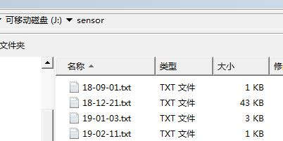

**How to upgrade system firmware?**

1 Connect the device and computer with micro-USB data cable, XP/WIN7 can be used, WIN8/WIN10 has not been tested.

2 Shut down first, press and hold the 2 buttons on the right side on the same time, then turn on the machine to enter the system security mode. At this point the buzzer will call.

3 Check that there is a 2 – 4MB disk on your computer:



4 Enter the ./update directory of the disk:

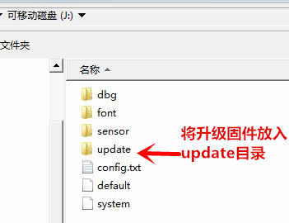

5 Put the firmware, the file format is *.bin, and put it in the update directory.

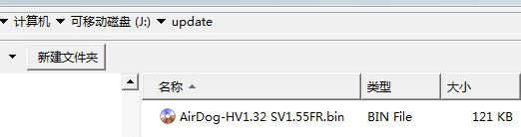

6 Restart, the system will be black screen for about 20 seconds, then automatically boot. Check the boot version number carefully. If the boot version number is the same as the firmware file name, the upgrade is successful. Otherwise the upgrade fails.

7 Precautions

Although the disk can be directly connected to the computer while the system is running, it is easy to cause the disk to become stuck. It is recommended to upgrade in safe mode.

**How to use TF card to store sensor data?**

1 A micro-SD card (ie TF card) and a card reader are required.

2 Insert the TF card into the card reader and insert it into your computer.

3 Format the TF card, pay attention to the disk capacity and name, do not select the wrong disk! ! File system select FAT format! ! Choose Quick Format. Other parameters can be used by default. Be sure to follow the configuration:

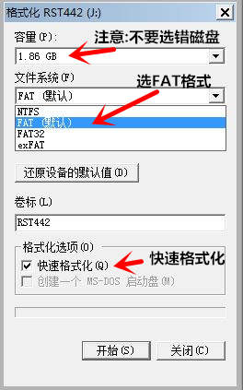

4 Here, my TF card capacity is 2G and the disk number is J. Users need to choose according to their own TF card.

5 After the format is successful, insert the TF card into the TF port of the detector.

6 Read sensor data: Take the TF card out of the detector, insert it into the card reader, and copy the sensor data from the computer.

7 Note:

Do not connect the AIRDOG directly to the computer, then read the data of the TF card and the computer will be stuck. When this happens, turn off the detector and remove the TF card.

In the process of using the TF card, if it is found that it cannot be read, cannot be written, etc., reformat the TF card. Generally caused by irregular operations.